Linguistic Areality in the Hindu Kush and the “Dardic” question
Henrik Liljegren (Stockholm University)
The northwestern-most outpost of Indo-Aryan, wedged in between Iranian and Tibetan languages in the mountainous Hindu Kush region, has been subject to a great deal of discussion and controversy. A term that in the past was applied collectively to these 30+ linguistic varieties – often with vague and shifting reference – is “Dardic”. Although few modern-day specialists hold on to this legacy term, it continues to be used by less diligent scholars or writers, while the derivation “Dardistan” recently has been reassigned a role in an ongoing assertion of indigenous rights in the region. In this talk I hope to present a nuanced and empirically based picture of the many Indo-Aryan linguistic communities at home in a largely contiguous zone covering northeastern Afghanistan, the mountainous north of Pakistan and adjacent areas under Indian control. This will be done from a descriptive as well as a typological perspective, illustrating both shared properties, areality and great diversity. The data and analysis displayed are the results of nearly 30 years of scholarly work, including longer stretches of fieldwork, collaborative data collection, corpus building and quantitative applications.
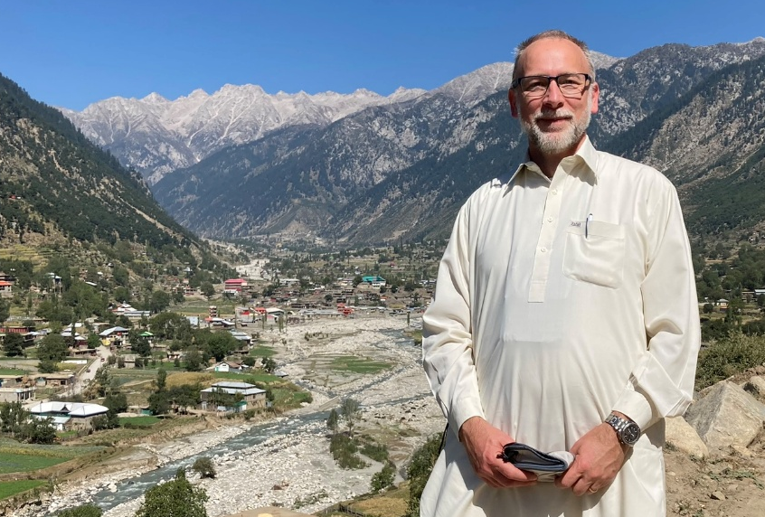
Bio note: Henrik Liljegren is a professor in General Linguistics at Stockholm University, specialized in language documentation and description. His main interests are areal typology, language contact and the languages of the Greater Hindu Kush. Many of those languages are lesser-described, endangered and under-resourced. He has carried out fieldwork in individual languages of the region as well as conducted areal-typological research by means of collaborative methods. His grammar of Palula is one of only a handful of comprehensive grammatical descriptions of Indo-Aryan languages spoken in the region. Apart from research per se, he has been engaged in language maintenance efforts, orthography design and in advising and coaching local communities in language documentation. He is one of the co-founders of the Forum for Language Initiatives (FLI), a resource and educational centre for language communities in Pakistan’s mountainous North.
Selected publications
Liljegren, Henrik. “Gawarbati Deaspiration: An Areal Feature of Western Hindu Kush.” In The Spatial Diffusion of Linguistic Changes: New Methods and Theoretical Perspectives, edited by Andrés Enrique-Arias, Carlota de Benito Moreno, and Florencio del Barrio de la Rosa. Studies in Language Change 26. De Gruyter Mouton, 2026. https://www.degruyterbrill.com/document/doi/10.1515/9783111615806-010/html?lang=en.
Panova, Anastasia, and Henrik Liljegren. “Locative and Existential Predication Contrasts in Gawarbati (Indo-Aryan) and the Surrounding Region.” In Language Science Press, edited by Chris Lasse Däbritz, Josefina Budzisch, and Rodolfo Basile. Language Science Press, 2025. https://doi.org/10.5281/zenodo.16759903.
Liljegren, Henrik. “Linguistic Areality in Northeastern Afghanistan.” In On the Place of Linguistics in Northern Afghanistan: A Tribute to Simone Beck, edited by Eberhard Werner and Wayne Lunsford. Publications in Linguistics 156. SIL International Global Publishing, 2025.
Liljegren, Henrik. “The Languages of Peristan through the Lens of Areal Typology.” In Roots of Peristan: The Pre-Islamic Cultures of the Hindukush/Karakorum, edited by Alberto Cacopardo and Augusto Cacopardo. Serie Orientale Roma, Nuova Serie 37. ISMEO - Associazione Internazionale di Studi sul Mediterraneo e l’Oriente, 2023.
Radloff, Carla F., and Henrik Liljegren. “Ergativity and Gilgiti Shina.” In Languages of Northern Pakistan: Essays in Memory of Carla Radloff, edited by Joan L. G. Baart, Henrik Liljegren, and Thomas E. Payne. Oxford University Press, 2022.
Liljegren, Henrik. “Nuristani in Its Areal and Typological Context.” International Journal of Diachronic Linguistics and Linguistic Reconstruction 19 (2022): 201–65. https://doi.org/10.29091/9783752002348.
Liljegren, Henrik, Robert Forkel, Nina Knobloch, and Noa Lange. “Hindu Kush Areal Typology.” Version v1.0. Zenodo, February 11, 2021. https://doi.org/10.5281/ZENODO.4534221.
Liljegren, Henrik. “The Hindu Kush–Karakorum and Linguistic Areality.” Journal of South Asian Languages and Linguistics 7, no. 2 (2020): 239–85. https://doi.org/10.1515/jsall-2021-2027.
Liljegren, Henrik. “Emerging Epistemic Marking in Indo-Aryan Palula.” In Evidentiality, Egophoricity and Engagement, edited by Henrik Bergqvist and Seppo Kittilä. Studies in Diversity Linguistics 30. Language Science Press, 2020. https://langsci-press.org/catalog/book/261.
Liljegren, Henrik. “Palula Dictionary.” Dictionaria, no. 3 (2019): 1–2700.
Liljegren, Henrik. “Gender Typology and Gender (in)Stability in Hindu Kush Indo-Aryan Languages.” In Grammatical Gender and Linguistic Complexity I: General Issues and Specific Studies, edited by Francesca Di Garbo, Bruno Olsson, and Bernhard Wälchli. Studies in Diversity Linguistics 26. Language Science Press, 2019. https://langsci-press.org/catalog/book/223.
Liljegren, Henrik. “Supporting and Sustaining Language Vitality in Northern Pakistan.” In The Routledge Handbook of Language Revitalization, 1 edition, edited by Leanne Hinton, Leena Huss, and Gerald Roche. Routledge, 2018.
Heegård, Jan, and Henrik Liljegren. “Geomorphic Coding in Palula and Kalasha.” Acta Linguistica Hafniensia 50, no. 2 (2018): 129–60. https://doi.org/10.1080/03740463.2018.1432210.
Liljegren, Henrik, and Afsar Ali Khan. “Khowar.” Journal of the International Phonetic Association 47, no. 02 (2017): 219–29. https://doi.org/10.1017/S0025100316000220.
Liljegren, Henrik. “Profiling Indo-Aryan in the Hindukush-Karakoram: A Preliminary Study of Micro-Typological Patterns.” Journal of South Asian Languages and Linguistics 4, no. 1 (2017): 107–56. https://doi.org/10.1515/jsall-2017-0004.
Liljegren, Henrik. A Grammar of Palula. Studies in Diversity Linguistics 8. Language Science Press, 2016. https://langsci-press.org/catalog/book/82.

